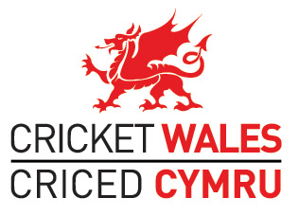
Agenda for the sixth Annual General Meeting of Cricket Wales to be held at 2pm on Sunday 1st October 2017 at The Metropole Hotel, Llandrindod Wells
- Chair’s Welcome

- Apologies for Absence

- To approve the minutes of the Cricket Wales AGM held on 2nd October 2016 (attached)

- Chair’s Report (verbal report)

- Chief Executive Officer’s Report (attached)

- Financial Report:

  - Audited accounts April 2016 to March 2017 (To b placed on www.cricketwales.org.uk and also to be circulated on the day);
  - Audit tender for April 2017 to March 2018 accounts

- Ratification of Board Directors for Cricket Wales:

  - Report from the Chair of the 2017 Cricket Wales Nominations Panel (to be circulated);
  - Biographies of proposed Directors (attached)
  - Formal ratification of Board Directors (attached)

- Equality, Diversity and Inclusion (verbal report)

- Close

